GROUP 1
Anonymized Group List
Development Team Project: Risk Identification Report
Risk Identification Report: Pampered Pets Digitalisation
Executive Summary
Pampered Pets is a small UK pet food retailer with limited digital infrastructure and a strong local supply network. This report compares current cyber, operational and supply chain risks with those likely to arise from digitalisation. The present model has limited reach and depends on few systems. Local suppliers provide short lead times and direct quality oversight, giving the business resilience that should not be discounted when considering change.
A phased approach is recommended, beginning with existing technology weaknesses before introducing improved inventory management and a modest e-commerce service. International sourcing requires greater caution because the proposed 24 percent saving has not been demonstrated against wider costs. A hybrid model would allow savings to be tested while retaining local supply resilience.

Introduction and Scope
Pampered Pets employs four staff and conducts 90 per cent of sales face-to-face. Email orders, digital sales records, a warehouse spreadsheet and wireless connectivity already support operations. Its reputation is closely linked to high-quality pet food and ingredients from nearby suppliers.
The assessment compares the current model with proposed e-commerce, hosted payments, cloud inventory and digital marketing. International sourcing is assessed separately because online growth does not require replacement of the existing supply network.

Current State Risk Assessment
Methodology
ISO 31000:2018 provides the overarching framework for strategic, operational, supply chain and cyber risk (ISO, 2018). ISO/IEC 27005:2022 and NIST SP 800-30 Rev. 1 support information-security risk identification (ISO, 2022; NIST, 2012). Key assets include the warehouse PC, sales records, customer data and supplier base.
A 5×5 likelihood and impact matrix is used, with scores of 1–4 rated Low, 5–9 Moderate, 10–16 High and 17–25 Critical. The case provides no incident history, technical inspection, customer research, supplier quotations or detailed financial data, so the scores are used to compare risks rather than claim precise probabilities. The 50, 24 and 33 per cent estimates are therefore treated as assumptions to be tested.

Table 1: Current State Risk Assessment for Pampered Pets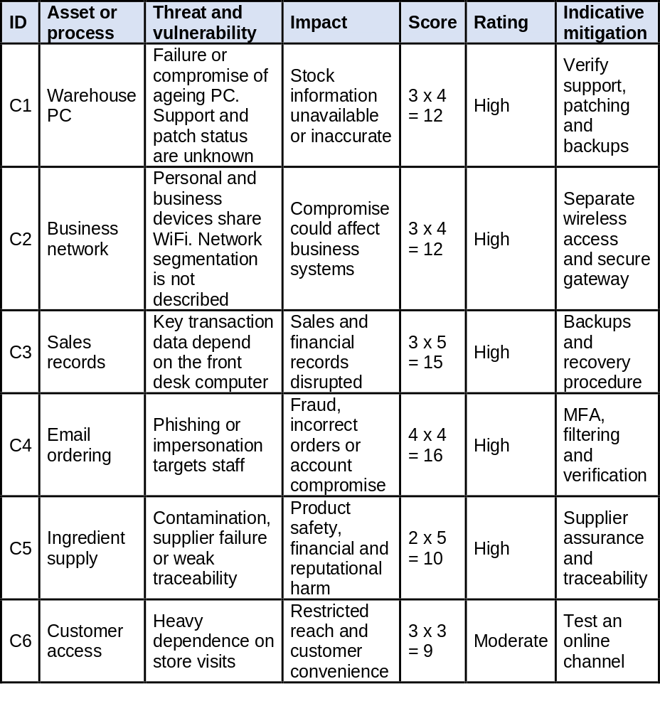
The 2024 government survey found that 32 per cent of UK micro businesses identified a breach or attack (DSIT, 2024). This does not show that Pampered Pets faces the same likelihood, but it does place its existing cyber risks in context. For this business, the greater concern is how much disruption could happen if one of its few systems or staff members became unavailable.
The local supply model also presents a trade-off. Relying on nearby suppliers creates some geographic concentration, but Pampered Pets can inspect ingredients directly and collect supplies quickly when needed. Moving towards international sourcing could weaken those advantages, so any cost saving needs to be weighed against quality control and continuity of supply. Feed registration, traceability and safety requirements should also be confirmed (Food Standards Agency, 2017).

Digitalisation Risk Assessment
Proposed Changes and Method
The proposed model includes e-commerce, hosted payments, cloud inventory, point-of-sale management and digital marketing. International suppliers could be tested without replacing the local network.
ISO 31000 is retained for comparability. STRIDE tests how identity abuse, data tampering, information disclosure and service interruption could affect proposed digital services (Microsoft, 2022). For e-commerce, account spoofing and order-data tampering emerge as priority threats, informing MFA and access controls.

Table 2: Proposed Digitalisation Risk Assessment for Pampered Pets
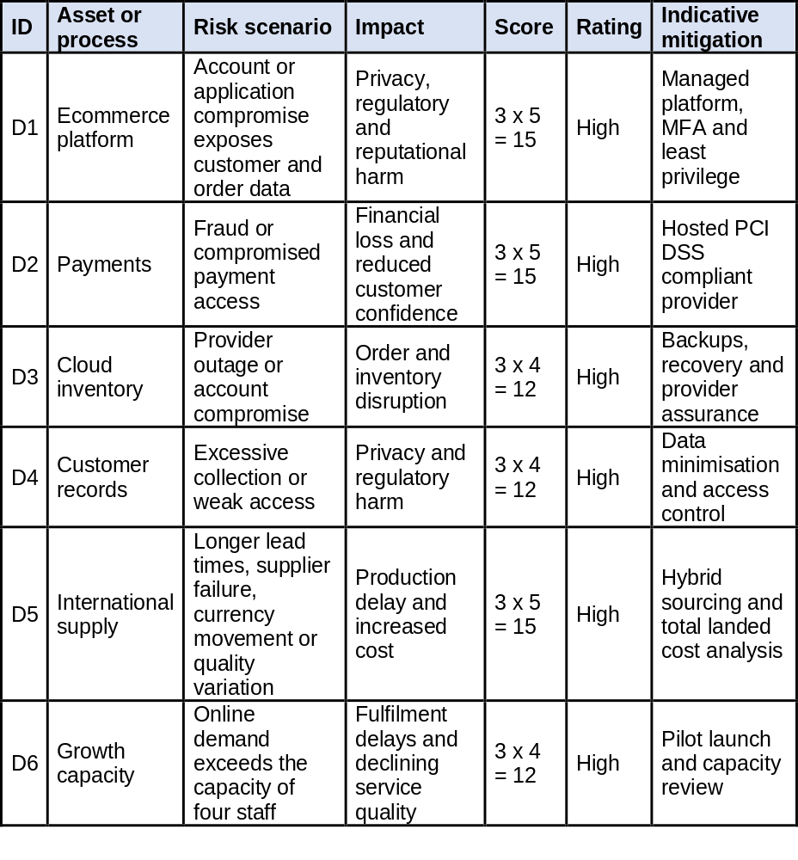
Digitalisation would increase dependence on online services, third-party providers and customer data, making data minimisation and access controls more important (ICO, 2023). Sagala and Őri’s (2024) review highlights the value of capability-aligned, incremental SME digitalisation. For Pampered Pets, expansion should follow evidence that its four-person operation can absorb the additional burden.

Comparative Analysis
Could an online presence increase the business by up to 50 per cent?
The opportunity is credible, but the evidence does not support a 50 per cent growth forecast. Online sales represented 26.6 per cent of Great Britain retail sales in January 2024, showing established digital purchasing without predicting Pampered Pets’ growth (ONS, 2024). With four staff and some products prepared in house, rapid demand could pressure service quality. The key uncertainty is therefore capacity, not demand alone. A limited launch could test conversion, contribution margin, repeat purchasing and fulfilment capacity.

Could international sourcing reduce costs by up to 24 per cent?
The 24 per cent claim is harder to support. Lower unit prices capture only part of the sourcing decision because freight, customs, currency exposure, additional inventory, quality assurance and longer lead times could narrow any saving. The present supply network also provides direct quality oversight and rapid replenishment. The decision is therefore about total landed cost and resilience, not unit price alone. A hybrid approach would test whether international sourcing delivers a measurable net benefit while retaining local suppliers.

Could 33 per cent of customers be lost without online features?
The case provides no evidence that one third of customers would leave. The more defensible risk is channel concentration because 90 per cent of sales still require a store visit. Online ordering may appeal to customers seeking convenience, while face-to-face service and local identity may support loyalty. Adding a digital channel would test demand without abandoning the established service model.

Recommendation
Based on the evidence available, phased digitalisation appears to offer Pampered Pets the stronger risk-adjusted option because it addresses existing weaknesses while retaining strengths that support quality and resilience.
Phase 1: Secure the current base. The warehouse PC should be checked and replaced if it cannot be secured. Business and personal wireless access should be separated, MFA introduced and critical records protected through tested backups. These controls address the high-rated current risks C1 to C4 and reduce the chance of existing weaknesses being carried into later phases.
Phase 2: Improve internal systems. Cloud inventory and sales management could reduce front-desk dependency and improve stock visibility. Role-based access, staff training and recovery procedures should accompany implementation. Progress should be judged by stock accuracy, order handling and reliability before further investment.
Phase 3: Test e-commerce. E-commerce should begin as an additional sales channel using a limited range and hosted payments. Expansion should depend on conversion, contribution margin, repeat purchasing, fulfilment capacity and service quality.
International sourcing should remain a separate business case. Selected products could be trialled while local suppliers are retained, allowing total cost, quality, lead times and continuity to be compared. Wider adoption would be justified only if a reliable net benefit is demonstrated without unacceptable quality or continuity risk.
Further investment should proceed only where measured benefits justify residual risk. For Pampered Pets, this means securing the current systems and improving internal operations before committing significant resources to e-commerce.

References
Department for Science, Innovation and Technology (DSIT) (2024) Cyber security breaches survey 2024. London: Department for Science, Innovation and Technology. Available at: https://www.gov.uk/government/statistics/cyber-security-breaches-survey-2024 (Accessed: 27 August 2026).
Food Standards Agency (2017) Starting an animal feed business. GOV.UK, 5 December. Available at: https://www.gov.uk/government/publications/starting-an-animal-feed-business (Accessed: 27 August 2026).
Information Commissioner's Office (ICO) (2023) A guide to the data protection principles. Wilmslow: Information Commissioner's Office. Available at: https://ico.org.uk/for-organisations/uk-gdpr-guidance-and-resources/data-protection-principles/ (Accessed: 27 August 2026).
International Organization for Standardization (ISO) (2018) ISO 31000:2018 Risk management: Guidelines. Geneva: International Organization for Standardization.
International Organization for Standardization (ISO) (2022) ISO/IEC 27005:2022 Information security, cybersecurity and privacy protection: Guidance on managing information security risks. Geneva: International Organization for Standardization.
Microsoft (2022) Microsoft Threat Modeling Tool threats. Microsoft Learn. Available at: https://learn.microsoft.com/en-us/azure/security/develop/threat-modeling-tool-threats (Accessed: 27 August 2026).
National Institute of Standards and Technology (NIST) (2012) SP 800-30 Rev. 1: Guide for Conducting Risk Assessments. Gaithersburg, MD: National Institute of Standards and Technology.
Office for National Statistics (ONS) (2024) Retail sales, Great Britain: January 2024. Newport: Office for National Statistics. Available at: https://www.ons.gov.uk/businessindustryandtrade/retailindustry/bulletins/retailsales/january2024 (Accessed: 27 August 2026).
Sagala, G.H. and Őri, D. (2024) 'Toward SMEs digital transformation success: a systematic literature review', Information Systems and e-Business Management, 22, pp. 667–719. doi: 10.1007/s10257-024-00682-2.

